PIZZA SALES SQL QUERIES
- KPI’s

- Total Revenue:
SELECT SUM(total_price) AS total_revenue
FROM pizza_sales;
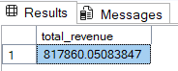

- Average Order Value:

SELECT SUM(total_price)/COUNT(DISTINCT order_id) AS avg_order_value
FROM pizza_sales;

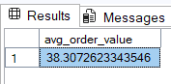

- Total Pizza Sold
SELECT SUM(quantity) AS total_pizza_sold
FROM pizza_sales;
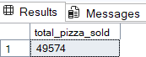

- Total Orders

SELECT COUNT(DISTINCT order_id) AS total_orders
FROM pizza_sales;
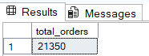

- Average Pizzas Per Orders

SELECT
CAST(CAST(SUM(quantity) AS DECIMAL(10,1)) / COUNT(DISTINCT order_id) AS DECIMAL(10,2)) AS avg_pizzas_per_orders
FROM pizza_sales;

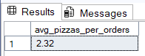

CHARTS REQUIREMENT

- Daily Trend for Total Orders

SELECT DATENAME(DW, order_date) AS order_day,
COUNT(DISTINCT order_id) AS total_sold
FROM pizza_sales
GROUP BY DATENAME(DW, order_date)
ORDER BY total_sold;

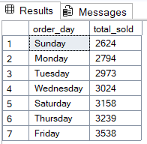

- Monthly Trends for Total Orders

SELECT DATENAME(MONTH, order_date) AS months,
COUNT(DISTINCT order_id) AS monthly_orders
FROM pizza_sales
GROUP BY DATENAME(MONTH, order_date)
ORDER BY monthly_orders;

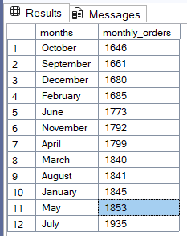

- Percentage of Sales by Pizza Category

SELECT pizza_category,
CAST(SUM(total_price) * 100 / (SELECT SUM(total_price) FROM pizza_sales) AS DECIMAL(10,2)) AS percentage_of_sales
FROM pizza_sales
GROUP BY pizza_category
ORDER BY percentage_of_sales DESC;
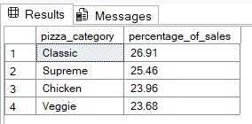

- Percentage of Sales by Pizza Size

SELECT pizza_size,
CAST(SUM(total_price) * 100/ (SELECT SUM(total_price) FROM pizza_sales) AS DECIMAL(10,2)) AS percenteage_of_sales
FROM pizza_sales
GROUP BY pizza_size
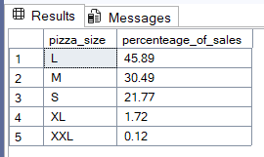
ORDER BY percenteage_of_sales DESC;

- Total Pizzas Sold by Pizza Category

SELECT pizza_category,
SUM(quantity) AS total_quantity
FROM pizza_sales
GROUP BY pizza_category
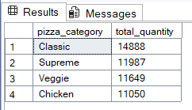
ORDER BY total_quantity DESC;

